**Real-time Global Illumination using Voxel-based Ray-bundles**

**A Master’s Thesis Proposal**

**by**

**Che Sun**

**Advisor: Emmanuel Agu**

**Reader: _____________**

**Department of Computer Science**

**Worcester Polytechnic Institute**

**Abstract**

Real-time Global Illumination (GI) has gained more and more interests in recent years due to the rapid evolvement of GPU computing power. Several approaches have been proposed to simulate global illumination as accurate as possible by implementing robust ray-tracing algorithms using Shader Model 5 features of current GPUs. For example, bidirectional path tracing is employed to resolve the classic singularity issue of instant radiosity. While the rendering speed is acceptable for a certain level of scene complexity, maintaining high frame rates for arbitrary scenes is still challenging. In this thesis, we propose a novel hybrid GI rendering system that combines bidirectional path tracing and scene voxelization to accelerate virtual point light (VPL) visibility tests and global ray-bundles generation. To demonstrate the power of our technique, we will show that caustic maps can be integrated into the system easily as well. Rendering speed improvements achieved by our method will also be benchmarked.

Keywords: real-time global illumination, instant radiosity, global ray-bundles, scene voxelization, caustic maps

**1. Introduction**

Global illumination is an important lighting effect that simulates light propagation behavior in 3D space. It increases fidelity of computer generated images dramatically and thus has been an active research area in the field of image synthesis. Since the formal introduction of the rendering equation [Kajiya 1986], many CPU-based off-line algorithms have been invented to solve it. While these techniques generate physically correct images, the speed of creating them is usually slow.

In order to implement global illumination rendering for real-time applications such as video games, many approaches are proposed. One class of these approaches is called many-light based method, derived from Keller [Keller 1997]. It provides a simple lighting computation framework that transforms the problem of solving lighting transport equation to the calculation of the direct illumination from many virtual light sources. This algorithm is hardware-friendly algorithm and can easily be implemented on modern GPUs . One shortcoming of the algorithm is that it requires many shadow maps to be generated for VPL visibility tests, which makes the algorithm less efficient.

Another class of real-time global illumination methods use so-called “voxels” to discretize the original scene representation. There are several advantages using scene voxelization: First, it is a geometry-independent scene description and some fast scene voxelization methods have been developed. Second, ray-geometry intersection and visibility tests can be performed very fast on such data structures. Third, high quality anti-aliasing techniques can be implemented using voxelization as well [Crassin 2011].

Global ray-bundles [Tokuyoshi 2012] is a hardware-friendly algorithm as well. This advantage makes it a promising technique for the acceleration of real-time ray tracing algorithms.

In this thesis, we introduce a hybrid real-time global illumination system which combines the many-light method, scene voxelization and global ray-bundles together. By doing so, both good rendering quality and speed could be achieved.

**2. Related Work**

To improve the rendering quality of Instant Radiosity [Keller 1997], [Tokuyoshi 2012] changed the sampling strategy of VPL to bidirectional path tracing. This algorithm is known to be robust and resolves the failure of VPL sampling strategy successfully. They implement the algorithm on Shader Model 5 featured GPU by using global ray-bundles [Sbert 1996] and GPU concurrent link list [Yang 2010].

However, global ray-bundles introduces additional burdens, since every time a VPL is used, every scene polygon must be rasterized again in order to create a global ray-bundles. Here, instead of generating sampling rays for each point being shaded, it generates a bunch of parallel rays using hardware rasterizer [Tokuyoshi 2012].

Voxel-based methods discretize the scene description and store discretized data in 3D grid cells. An outstanding feature of scene voxelization is that it is extremely fast (usually several million-seconds on current commodity GPUs). A drawback of using regular grids for voxelization is the high consumption of GPU memory. To solve this problem, [Crassin 2011] develops a Sparse Voxel Octree (SVO) based data structure and uses it for their high quality global illumination rendering: they employ a pre-filtering process to filter the geometric data in a bottom-up fashion. The resulting hierarchical octree structure is then used for their voxel cone tracing.

Caustics is another important lighting phenomenon that have gained much attention in the field of real-time rendering in recent years. [Shah et al. 2007] proposes Caustics Mapping, a technique simulates caustics in image space.

**3. Proposed Work**

We propose employing many-light, global ray-bundles and scene voxelization methods together to implement a robust and efficient real-time global illumination rendering system. Our novel rendering system shall be implemented fully based on shader model 5 features of commodity GPUs. We will also integrate an improved version of caustic maps technique into the system. Figure 1 shows an overview of the system.

**3.1 Investigating Instant Radiosity and many-light based methods**

Naïve many-light based method creates many virtual point lights (VPL) in each rendering frame by sampling the scene description and then uses shadow maps to do the visibility tests when shading a fragment. Although intuitive and simple to implement, this method reduces the frame rates a lot since VPL shadow maps creation requires sampling the scene description many times (usually 100 -1000). To accelerate the rendering speed. We investigate the following methods:

*Reflective shadow maps* [Dachsbacher and Stamminger 2005] captures scene surface points visible to light sources efficiently but ignores visibility test for VPLs. Segovia et al [Segovia 2006] uses *interleaved sampling* [Keller and Heidrich 2001] to reduce the number of VPLs needed for each pixel being shaded. Lane et al [Lane et al 2007] maintains a set of VPLs and regenerates a subset of them incrementally to reduce the overhead of VPL shadow map regeneration. Ritschel et al [Ritschel et al. 2008] employs *point-based rendering* for the VPL shadow maps. The key idea is that instead of using the original scene polygons, they use a set of point samples for the primitive rasterization process, which is much faster than the original polygon primitive rasterization. While using few VPLs is desirable, it leads to downsampling issues such as flickering especially when part of the scene is animated. To address this issue, Knecht [Knecht 2009] exploits temporal coherence [Nehab et al. 2007] to filter out high frequency signals between consecutive frames.

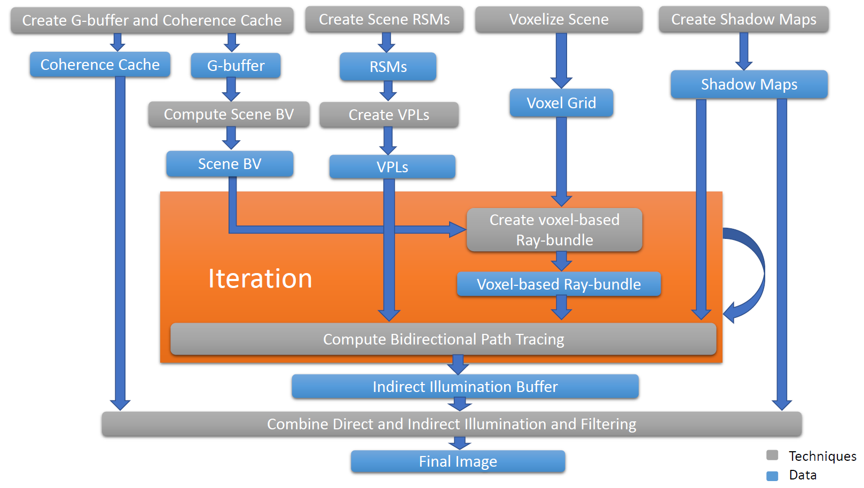

**Figure 1. Overview of our real-time bidirectional rendering system using voxel-based ray-bundles.**

**3.2 Investigating voxel-based global illumination methods**

The Many-lights method is a biased method. While bias could be reduced by increasing the number of virtual light sources, frame rates will suffer if too many virtual light sources are generated and used for rendering. Most existing many-light based real-time approaches use shadow maps for visibility tests during indirect illumination calculation, which is currently their main bottle neck. To resolve this bottle neck, we will investigate using voxel-based methods voxel data structure for VPL visibility tests.

**3.3 Investigating Real-time Bidirectional Path Tracing via Rasterization**

General real-time many-light methods also suffer from a singularity issue caused by failure of the sampling strategy at corners of scene geometry, where the distance between the shading point and the virtual light source is too small. One way of resolving this problem is clamping, which leads to incorrect rendering results. Tokuyoshi et al [Tokuyoshi 2012] introduces a better solution using bidirectional path tracing on GPU. They combine the many-light method with global ray-bundles method to construct a lighting path from both the virtual light source and the camera. Thus the overall rendering quality is improved. However, using global ray-bundles further increases the burden, because additional scene rendering task must be issued to create ray-bundles for each virtual light source. Thus we will focus on improving the rendering efficiency of this method.

**3.4 Implementing a hybrid real-time global illumination system**

We will replace the expensive VPL shadow maps generation task with a fast scene voxelization technique. Furthermore, we will use this voxelized scene description to generate voxel-based ray-bundles. This task should be much faster than the original method in [Tokuyoshi 2012].

**3.5 Investigating Adaptive Caustic Maps**

Generic caustic maps method consists of three steps: first, a photon buffer is created from the light’s view. Secondly, a caustic map is generated by splitting points in photon buffer. Finally, a caustic map is used for caustics rendering. Traditionally, the first step involves two-pass rendering of the refractor geometry which leads to inefficiency. Moreover, to ensure good caustics quality, more photons have to be used. This is the main bottle neck of the algorithm. Wyman and Nichols [Wyman and Nichols 2009] introduced adaptive caustic maps to reduce the cost of caustic map generation. The key idea is using a lazy algorithm that refines a coarse level buffer as needed (Add more photons where refractors exist). We will implement an improved version of caustics maps using GPU concurrent link list [Yang 2010]. Integration of this technique into our system shall be designed and implemented fully using Shader Model 5 features.

**4. Research Schedule**

**January – April 2014:** Learn OpenGL shader programming, Spherical harmonics, Light Propagation Volume, Reflective Shadow Maps, SSDO, Instant Radiosity, Many-light methods then Implement SSDO.

**May – August 2014:** Learn OpenCL and OpenGL compute shader programming, Real-time Bidirectional Ray Tracing via Rasterization, GPU concurrent link list technique, Global Ray-bundles, Imperfect Shadow Maps, Incremental Instant Radiosity and Interleaved Sampling. Meanwhile, implement Reflective Shadow Maps, GPU concurrent link list and global ray-bundles.

**September – December 2014:** Learn OpenGL geometry and tessellation shader programming then investigate Real-time voxelization, Temporal Coherence, Paraboloid Shadow Map, Caustic Maps. Meanwhile, implement VPL demo, voxelization demo and combine VPL and voxelization together to support voxel-based VPL visibility test.

**January – March 2015:** Implement voxel-based global ray-bundles and combine all the sub-systems together, then integrate caustic maps into the system.

**March – April 2015:** Write thesis, do thesis presentation and submission.

**References**

[Kajiya 1986] Kajiya, James T. "The rendering equation." *ACM Siggraph Computer Graphics*. Vol. 20. No. 4. ACM, 1986.

[Keller 1997] Keller, Alexander. "Instant radiosity." *Proceedings of the 24th annual conference on Computer graphics and interactive techniques*. ACM Press/Addison-Wesley Publishing Co., 1997.

[Tokuyoshi 2012] Tokuyoshi, Yusuke, and Shinji Ogaki. "Real-time bidirectional path tracing via rasterization."*in Proceedings ACM SIGGRAPH Symposium on Interactive 3D Graphics and Games* 2012.

[Crassin 2011] Crassin, C., Neyret, F., Sainz, M., Green, S., & Eisemann, E. (2011, September). Interactive indirect illumination using voxel cone tracing. In *Computer Graphics Forum* (Vol. 30, No. 7, pp. 1921-1930). Blackwell Publishing Ltd.

[Dachsbacher and Stamminger 2005] Dachsbacher, Carsten, and Marc Stamminger. "Reflective shadow maps." *Proceedings of the 2005 symposium on Interactive 3D graphics and games*. ACM, 2005.

[Segovia 2006] Segovia, B., Iehl, J. C., Mitanchey, R., & Péroche, B. (2006, September). Non-interleaved deferred shading of interleaved sample patterns. In *SIGGRAPH/EUROGRAPHICS Conference On Graphics Hardware: Proceedings of the 21 st ACM SIGGRAPH/Eurographics symposium on Graphics hardware: Vienna, Austria* (Vol. 3, No. 04, pp. 53-60).

[Keller and Heidrich 2001] Keller, Alexander, and Wolfgang Heidrich. *Interleaved sampling*. Springer Vienna, 2001.

[Lane et al 2007] Laine, S., Saransaari, H., Kontkanen, J., Lehtinen, J., & Aila, T. (2007, June). Incremental instant radiosity for real-time indirect illumination. In *Proceedings of the 18th Eurographics conference on Rendering Techniques* (pp. 277-286). Eurographics Association.

[Ritschel et al. 2008] Ritschel, T., Grosch, T., Kim, M. H., Seidel, H. P., Dachsbacher, C., & Kautz, J. (2008, December). Imperfect shadow maps for efficient computation of indirect illumination. In *ACM Transactions on Graphics (TOG)* (Vol. 27, No. 5, p. 129). ACM.

[Knecht 2009] Knecht, Martin. *Real-time global illumination using temporal coherence*. na, 2009.

[Nehab et al. 2007] Nehab, D., Sander, P. V., Lawrence, J., Tatarchuk, N., & Isidoro, J. R. (2007, August). Accelerating real-time shading with reverse reprojection caching. In *Graphics hardware* (Vol. 41, pp. 61-62).

[Sbert 1996] Sbert, Mateu, and Xavier Pueyo i Sàndez. *The Use of global random directions to compute radiosity: global Montecarlo techniques*. 1996.

[Yang 2010] Yang, J. C., Hensley, J., Grün, H., & Thibieroz, N. (2010, June). Real‐Time Concurrent Linked List Construction on the GPU. In *Computer Graphics Forum* (Vol. 29, No. 4, pp. 1297-1304). Blackwell Publishing Ltd.

[Shah et al. 2007] Shah, Musawir A., Jaakko Konttinen, and Sumanta Pattanaik. "Caustics mapping: An image-space technique for real-time caustics."*IEEE Transactions Visualization and Computer Graphics,* 13.2 (2007): 272-280.

[Wyman and Nichols 2009] Wyman, Chris, and Greg Nichols. "Adaptive caustic maps using deferred shading." *Computer Graphics Forum*. Vol. 28. No. 2. Blackwell Publishing Ltd, 2009.